DRUG RESEARCH ACADEMY

Biannual progress report
TEMPLATE FOR PHD STUDENTS AFFILIATED WITH DRA

Deadlines for submitting the biannual report: 1 May and 1 November.
Please note that the DRA progress report fulfils the requirements from the Graduate School as to the yearly regular assessment in PhD planner.

Detailed information can be found on the DRA website.

The purpose of the DRA progress reports is to help DRA PhD students to keep their PhD on track and ensure an efficient and continuous evaluation of the course of the PhD project:
- Tool and help to keep PhD on track and get all supervisors involved
- Training in thinking/planning ahead and taking charge of PhD
- Training in progress reporting for future employments
Step-by-step:
- Fill in the DRA progress report.
- Call a meeting with all your supervisors to discuss the report and summarize the contents of your discussions on the last page of the report (the meeting summary is mandatory).
- You can also use the elective evaluation questions as a supplement for the meeting.
- After the meeting, you must email the DRA progress report with the meeting summary to the DRA secretariat (dra@sund.ku.dk) with a copy to your supervisor(s).
- The DRA progress report fulfils the requirements from the Graduate School, i.e. when you are asked for the yearly regular assessment in PhD planner. Follow the instructions on Graduate School’s website.
Please contact the DRA secretariat:
- If you have any questions.
- If you are unable to meet the deadline for some reason (e.g. leave). We will then find an alternative deadline.
- If you have initiated your PhD project less than 3 months before the deadline, or if you have stopped collecting data and have initiated writing your thesis as you are then exempted.

DRA Progress Report

Name:

Project title:

Principal supervisor:

Co-supervisor(s):

External assessor:
(not mandatory)
Biannual report no.:

Date of submission:

1) Brief background of project (1/2 page max):

2) Aim (200 words max):
Overall aim(s) of the project

3) Status (1/2 page max):
Short overview of previous conclusions and progress in the literature of direct relevance
to the project (if any)

4) Intermediate goals for the current project period:
Bullet points, as discussed at the last meeting

5) Progress since last report including data (1-3 pages):

6) Future research plans (1/2 page max):
Bullet point listing. Include time schedule and priority for the next 6 months and until
handing in thesis

7) PhD courses taken (since enrolment):

Period | PhD course title | ECTS
 |  | Total:

8) Status for stay at another research environment:
Stay at another research environment (mainly abroad) for at least 1 month is mandatory (Graduate School rules). Please state planning stage of such a stay or whether it has already been conducted.

PhD Career Programme
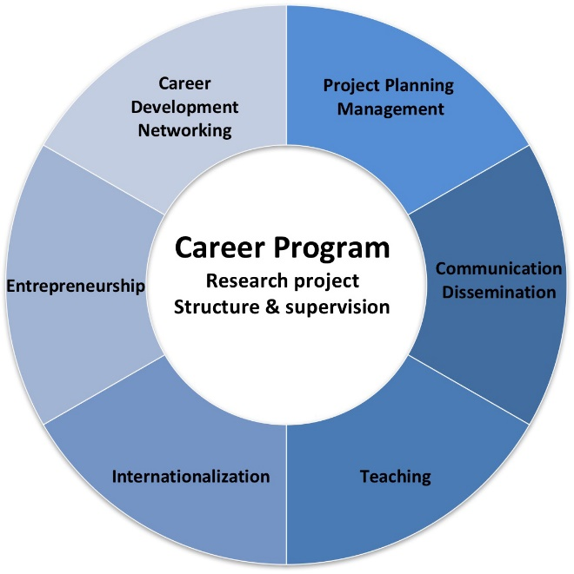
Every three years DRA conducts an employment survey of PhD graduates of the previous three years.

The surveys have clearly shown than skills beyond the research project and specific scientific methods are important for future careers.

This led DRA to initiate a PhD Career Programme with focus on six key training skill sets (TS1-6) shown on the figure, which are promoted through a mix of mandatory and elective courses, workshops and networking events.

TS1: Project Planning & Management
Mandatory elements | Recommended timing | Completed (date):
Scientific project planning and management I | ~6 months into PhD
Scientific project planning and management II | ~2 years into PhD
Biannual progress reports | May 1 / November 1
Elective elements |  | Completed (date):

TS2: Communication and dissemination
Mandatory elements | Recommended timing | Completed (date):
Evaluate posters at DRA Summer School | 1st year
Poster presentation at DRA Summer School | 2nd year
Oral presentation at DRA Summer School | 3rd year
Elective elements |  | Completed (date):
Inspiration for additional elective activities:
- Describe your PhD project on CURIS profile
- Workshops / courses organized by DRA in e.g.:
  - dissemination for non-scientific audience
  - scientific writing
  - presentation techniques
- Presentations at group/section meetings and conferences
- Participation in ULLA Summer School (poster presentation)

TS3: Teaching and Supervision
Mandatory elements | Recommended timing | Completed (date):
Introduction course in university pedagogy | As early as possible
Max 300 hrs. of teaching incl. preparation * | Throughout PhD
Teaching conducted:  Course titles: | Teaching hours: | Period:
 | Total:
Elective elements |  | Completed (date):
* Be aware of specific teaching requirements of your department, e.g. max 300 hours at Department of Pharmacy, 240 hours at Department of Drug Design and Pharmacology, and max 300 hours at Department of Biomedical Sciences

Inspiration for additional elective activities:
- Course in tutoring and supervision for students
- Use elective questionnaire on supervision expectations at regular intervals
- Use elective supervision evaluation questionnaire at regular intervals

TS4: Entrepreneurship
Elective elements | Completed (date):
Inspiration for elective activities:
- PhD courses such as "Intellectual Property Rights in Biotechnology and Drug Discovery" (SUND)
- DRA workshops with invited speakers to tell about their own experiences from idea to company
- Patenting inventions during the PhD
- Innovation cups
- Departmental innovation workshops

TS5: Internationalization
We encourage participation in at least 2 of the following 5 elements:
- Affiliate international co-supervisor or external assessor.
- Stay at another research environment abroad.
- Participate in an international conference/meeting.
- Participate in a PhD course abroad.
- Participate in an ULLA summer school or ULLA workshop.

Elements conducted | Completed (date):

TS6a: Career Development
Mandatory elements | Timing | Completed (date):
Performance and development review (MUS) | 1st year
 | 2nd year
 | 3rd year
Elective elements |  | Completed (date):
Inspiration for additional elective activities:
- Enter a mentor programme

TS6b: Networking
Mandatory elements | Timing | Completed (date):
Participate in DRA Summer School | 1st year
 | 2nd year
 | 3rd year
Elective elements |  | Completed (date):
Inspiration for additional elective activities:
- DRA lectures and symposia
- Networking events organized by e.g. the Young Pharma Forum (YPF)
- DRA workshops focused on networking
- ULLA summer school or ULLA workshop
- Become member of national & international scientific societies and participate in their activities
DRA Supervisor Meeting Summary
It is mandatory to complete the summary.

PhD student (name and signature) __________________________________________

Biannual report no ___________

Submitted (date) ___________

By submitting the report to DRA, the PhD student confirms that the biannual report has been approved by the supervisors, and a meeting between the PhD student, the principal supervisor and the co-supervisors has been held.

The following results achieved in the current 6-month project period were discussed:

The following plans and milestones for the next 6-month project period were discussed:

Remember to send a copy of the progress report and meeting summary to the DRA secretariat (DRA@sund.ku.dk).

